HANDS-ON 6 : Services & Dependency Injection
Project Structure:
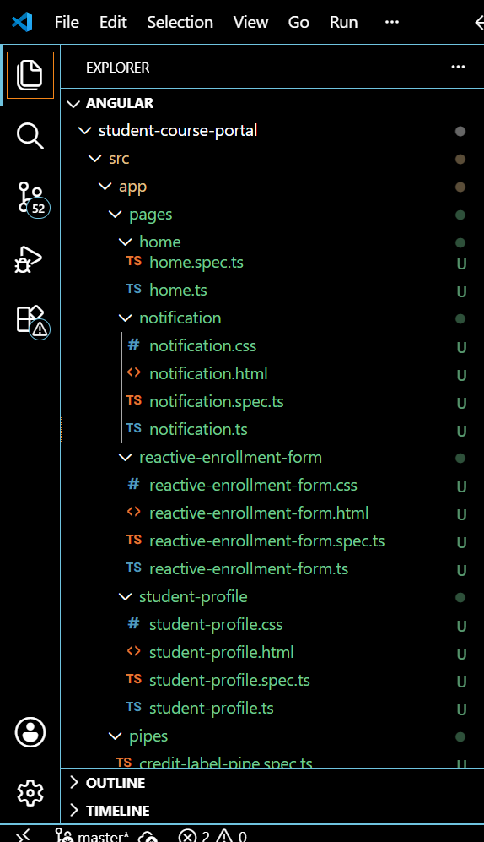
Notification.html
<div class="notification-box">
<h4>Notifications</h4>
<input [(ngModel)]="newMessage" placeholder="New message..." />
<button (click)="add()">Add</button>
<ul>
<li *ngFor="let msg of messages">{{ msg }}</li>
</ul>
</div>
Notification.ts
import { Component } from '@angular/core';
import { CommonModule } from '@angular/common';
import { FormsModule } from '@angular/forms';
import { NotificationService } from '../../services/notification';

@Component({
selector: 'app-notification',
imports: [CommonModule, FormsModule],
templateUrl: './notification.html',
styleUrl: './notification.css',
providers: [NotificationService]
// Providing NotificationService HERE (component-level) instead of root
// creates a NEW, separate instance scoped to this component and its
// children. Unlike CourseService/EnrollmentService (providedIn: 'root',
// one shared instance app-wide), every <app-notification> placed in the
// template gets its OWN isolated NotificationService — messages added
// in one instance never appear in another.
})
export class Notification {
newMessage = '';

constructor(private notificationService: NotificationService) {}

get messages(): string[] {
return this.notificationService.getMessages();
}

add(): void {
if (this.newMessage.trim()) {
this.notificationService.addMessage(this.newMessage.trim());
this.newMessage = '';
}
}
}
App.routes.ts
import { Routes } from '@angular/router';
import { Home } from './pages/home/home';
import { CourseList } from './pages/course-list/course-list';
import { EnrollmentForm } from './pages/enrollment-form/enrollment-form';
import { ReactiveEnrollmentForm } from './pages/reactive-enrollment-form/reactive-enrollment-form';
import { StudentProfile } from './pages/student-profile/student-profile';

export const routes: Routes = [
{ path: '', component: Home },
{ path: 'courses', component: CourseList },
{ path: 'enroll', component: EnrollmentForm }, // Task 1, Step 38
{ path: 'enroll-reactive', component: ReactiveEnrollmentForm }, // Hands-On 5
{ path: 'profile', component: StudentProfile } // Hands-On 6, Step 66
];
OUTPUT:
